Turnaround time = completion time – arrival time FCFS CPU scheduling finishes each job that arrives first, puts rest in queue

Sequence: 4 3 1 5 2

Wait time = turnaround time – burst time

Priority

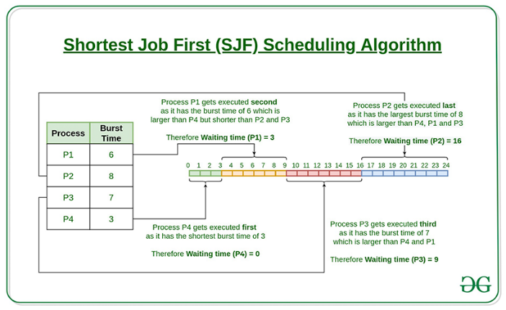 RR – cpu sched

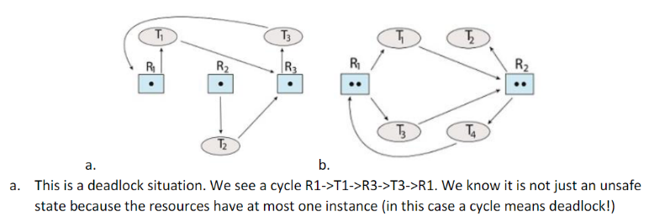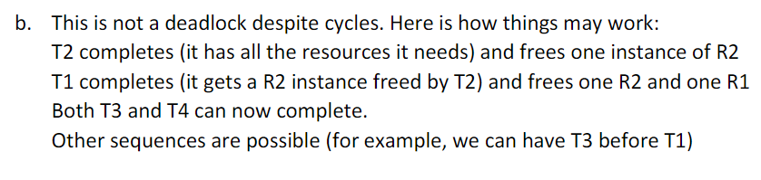

Deadlock

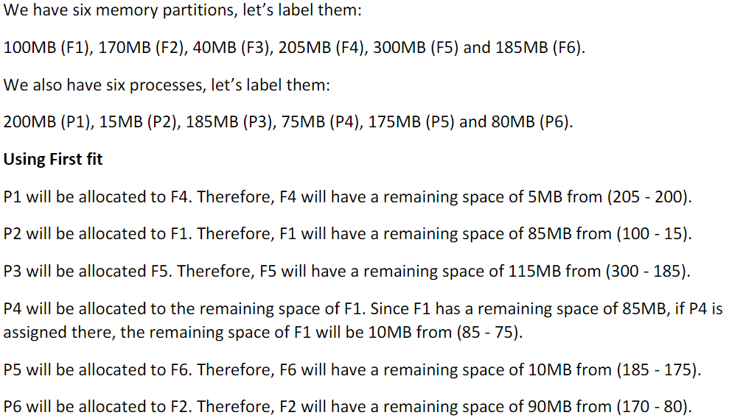

Resource request – Need = max - allocation

Available = available + allocation when need is less than available

First in first out – PAGE FAULTS = PAGES REPLACED

Optimal

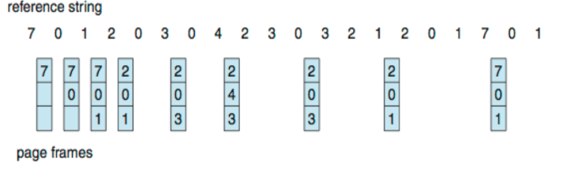

Least Recently Used